**ORANGE**

**Group No**:**c**

**Name**:Dholon Akter

**Student Number**:3047040

**Name**:Dat Le

**Student Number**:2901471

Table of Contents

**1 Introduction** **3**

2. Sitemap 3

3. Wireframes 4

4. Visual Design 13

# 1 Introduction

Orange is an international online shop that deals with an Europe and Asian clothes and electronics devices.

**Target Audience**

The target audience are both men and women within the range of 16 to above 60 years old.They can access the website through the internet with limited knowledge in English.

The website is also designed to everyone who do not want to spend too much time in the actual store. It is made to be fast and convenient by just some few clicks for the customers to be able to purchase our products.They can order the items with different payment system and get the items to their door within few working days.

## 2. Sitemap

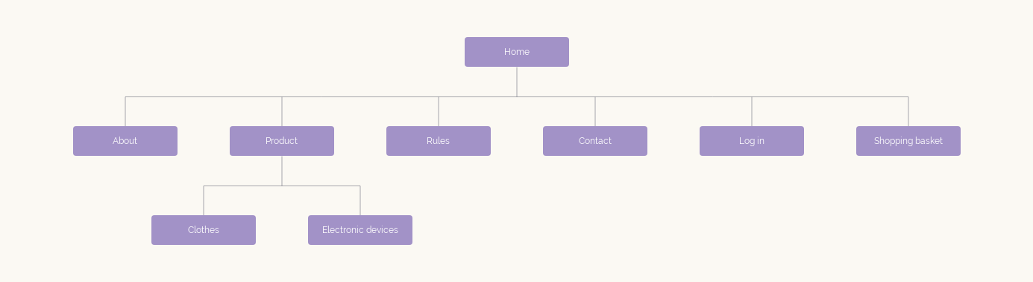

### 3. Wireframes

**Home page**

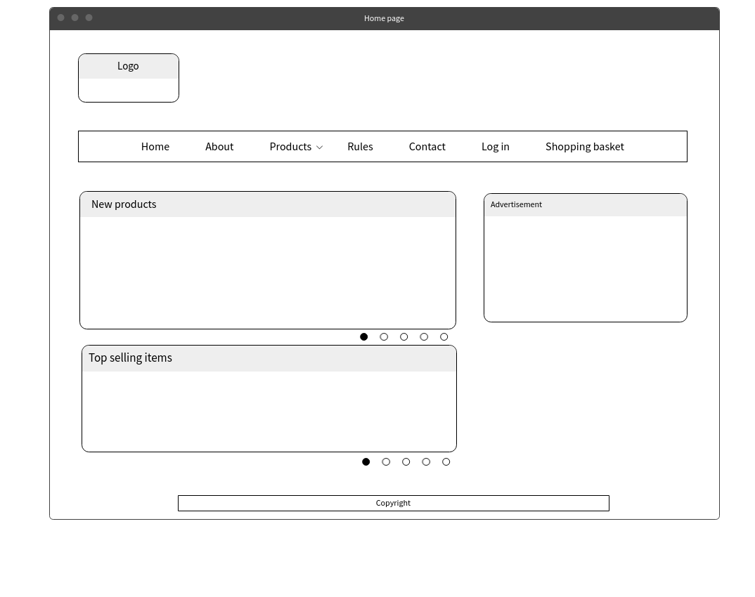

**About**

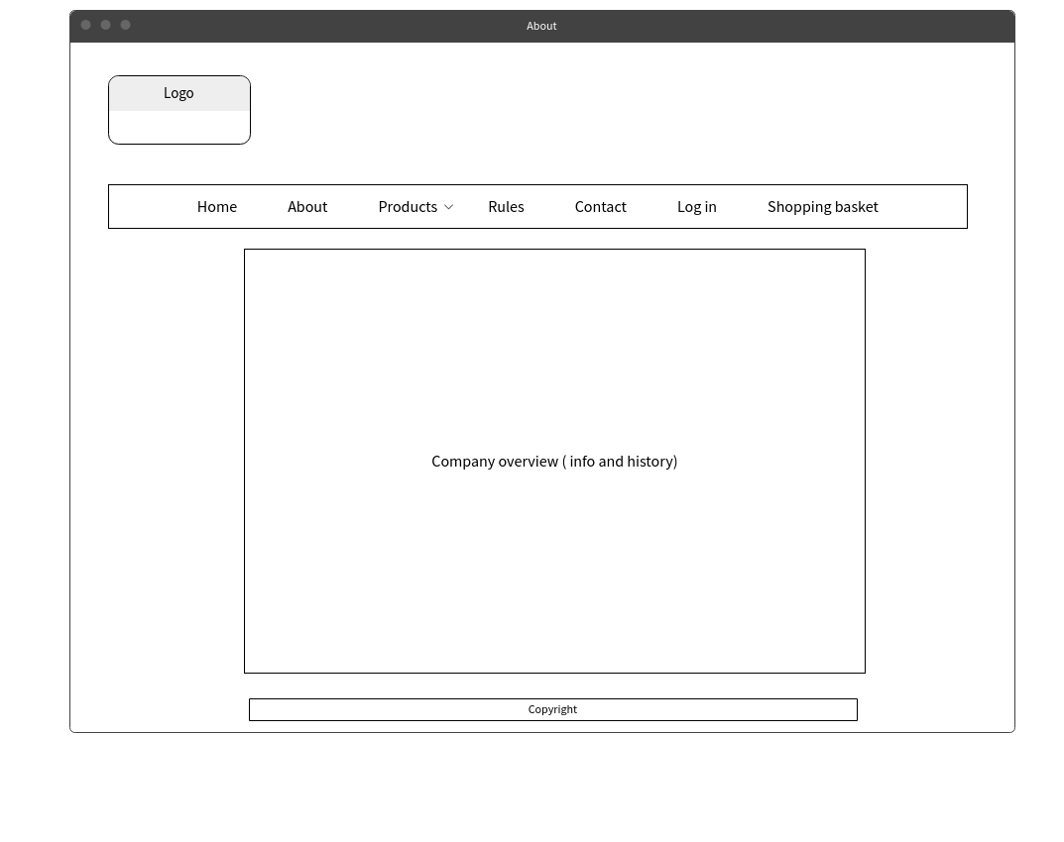

**Product**

**clothes**

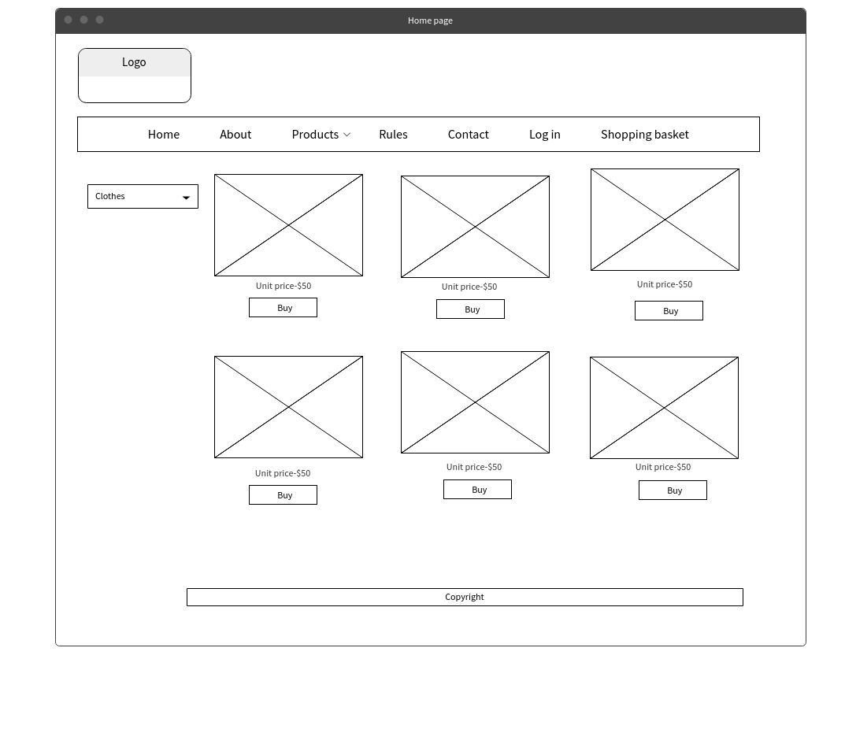

**Accessories**

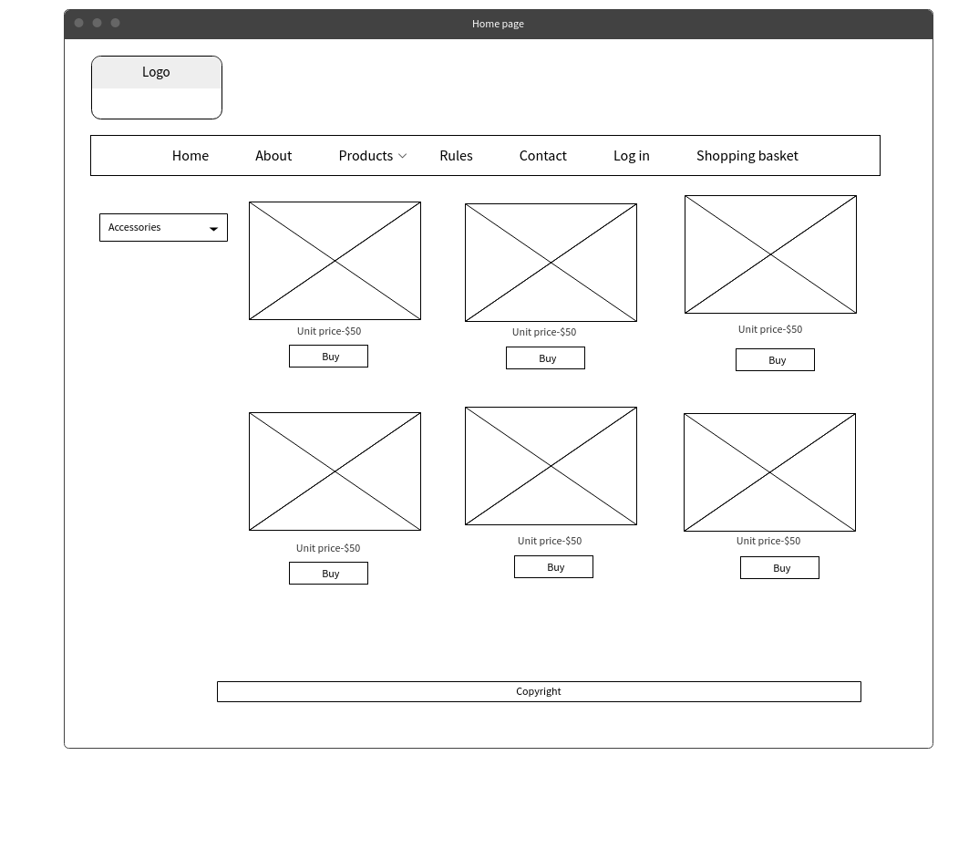

**Rules**

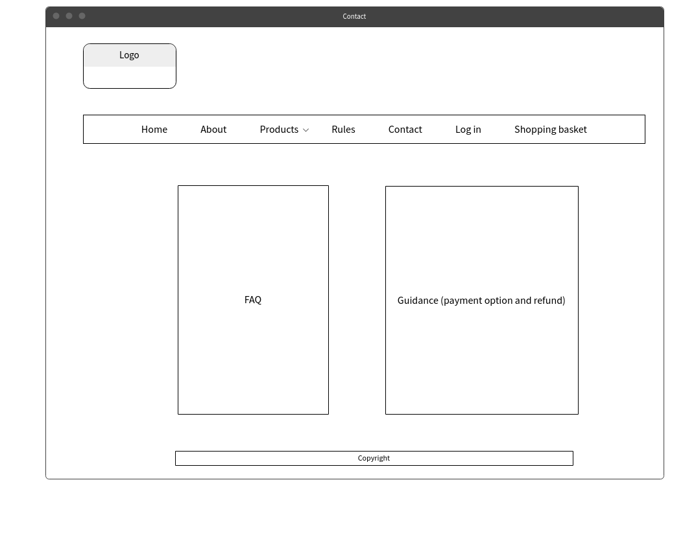

**Contact**

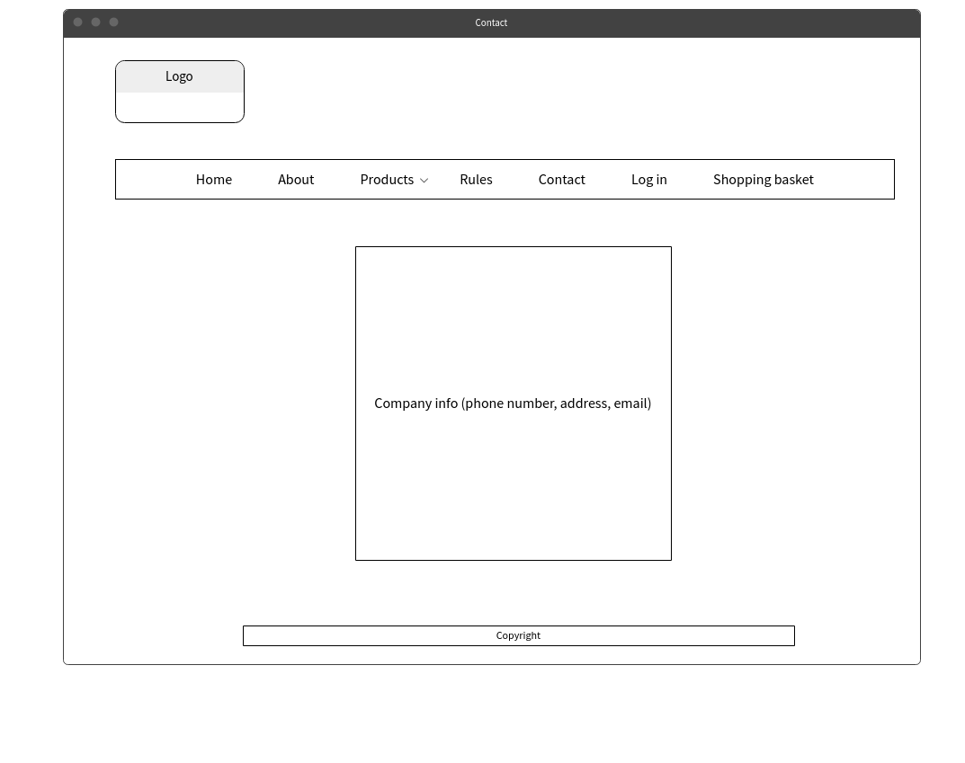

**Basket**

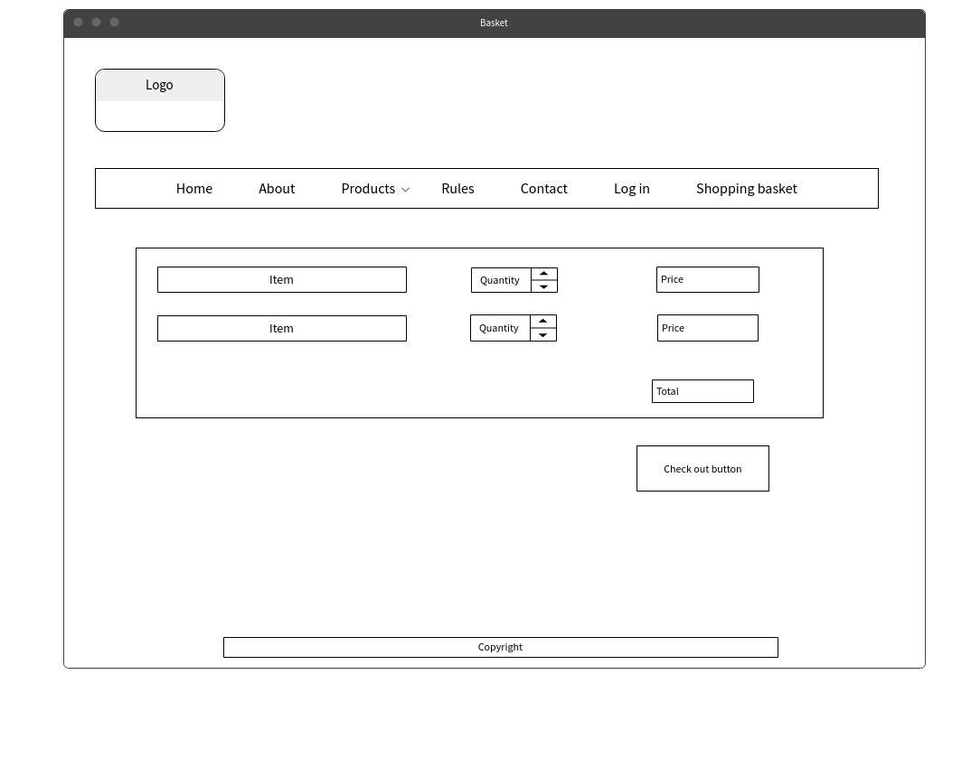

LogIn

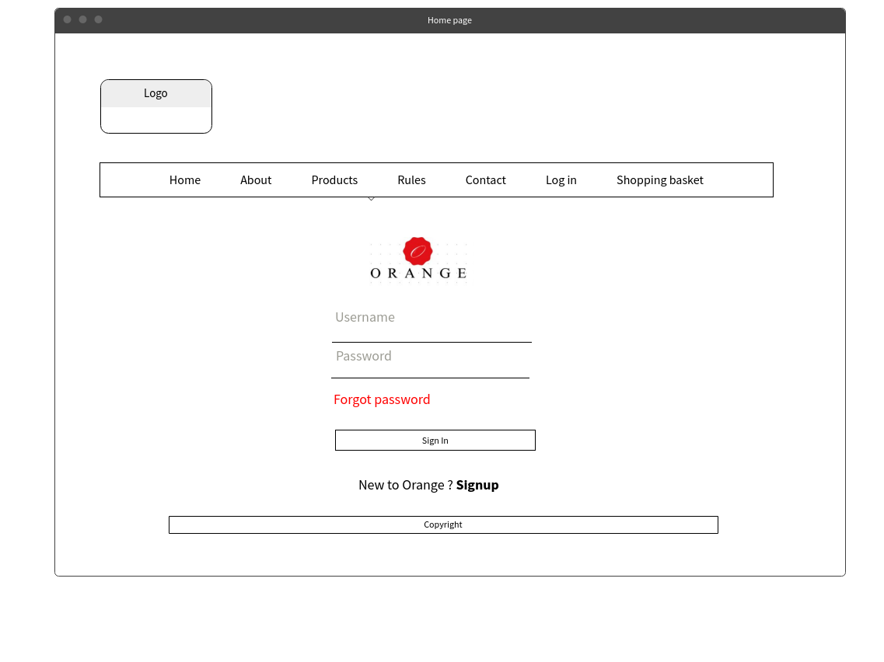

SignUp

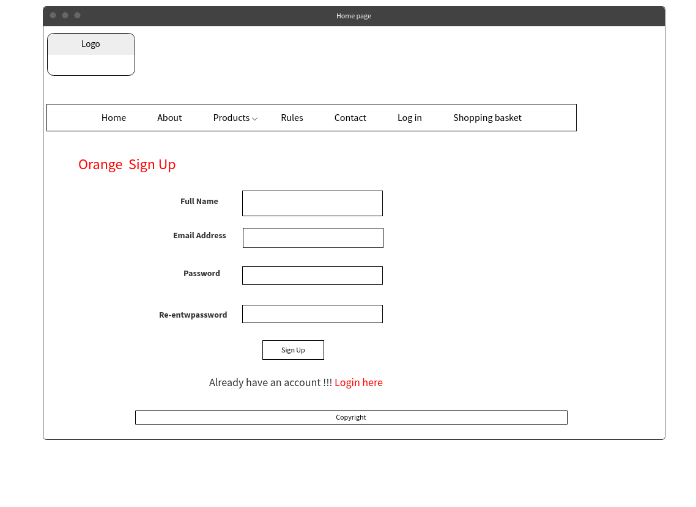

#### 4. Visual Design

